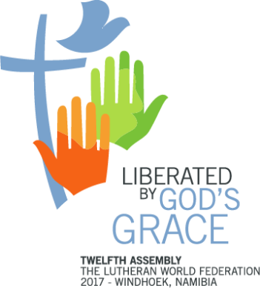
Twelfth Assembly Stewards
3 to 16 May 2017
Namibia

APPLICATION FORM

Please complete, sign and return this form to stewards2017@lutheranworld.org by 31 May 2016.

1. Last name:

2. First name:

3. Date of birth:

4. Nationality:

5. Postal address:

6. Tel no (best number to contact you by):

7. E-mail:

8. Language skills (Please state your knowledge as: proficient, good, fair or no knowledge)
English:
German:
French:
Spanish:
Other language/s:

9. Which LWF member church do you belong to?

10. List down relevant information with regards to your experience in church youth work at national, regional, and/or global levels

11. After having read the Stewards Guidelines, list down particular attributes and skills that you think might be helpful in your work as a Steward.

12. In less than 100 words, state your motivation for applying for the Twelfth Assembly Stewards program

13. Indicate your preference for work by assigning a number to each of the following tasks, with 1 signifying your most preferred task.

- Plenary hall (preparing the plenary hall for sessions, welcoming delegates, preparing a seating plan, distributing Assembly documents and interpretation equipment)

- Media and communications (assisting in the work of the Assembly communications office, e.g. preparing the daily Assembly newsletter, social media, organizing press conferences and briefings)

- Registrations, information and finance office (assisting in registrations, responding to practical queries, running errands)

- Worship (assisting in the logistics of preparing morning, midday and evening prayers)

- Space management (assisting in preparing breakaway rooms and ensuring set-up for side events and Village Groups, responding to spontaneous requests for meeting space)

14. Is your church willing to support your participation financially by:

a. Paying your travel:
b. Paying your accommodation of EUR35 per day (If partial please state amount)
c. Paying visa, travel and other in-country costs

Please attach a copy of your passport, a high resolution photo of yourself as well as a letter of recommendation signed by the head of your church council or Bishop. Send this form and other requirements to stewards2017@lutheranworld.org no later than 31 May 2016.

Date:
Signature:

